**MSC Advance Computer Science**

**Advanced Databases (CMP7214)**

**Project Report on**

**ZOO MANAGEMENT SYSTEM**

**Table of Contents**

1. Domain Deception: ........................................................................................................ 4

2. Database Analysis: ........................................................................................................ 4

2.1. Business Situation: .....................................................................................................4

2.2. Business Rules: .......................................................................................................... 5

2.3. List of Entity/Attributes: ........................................................................................... 5

2.4. Simple Relationships: .................................................................................................7

2.5 ERD Mapping: .............................................................................................................9

3. Database Design: ........................................................................................................ 23

3.1 ERD Diagram: ………………………………………………………………………………………………………..23

3.2 Database Design: ………………………………………………………………………………………………….24

4. Database Normalization: .............................................................................................. 25

5. Database Implementation: ………………………………………………………………….………………………………..28

6. Data Insertion: ……………………………………………………………………………………………………………………….41

7. SQL Queries ………………………………………………………………………………………………………………..………...51

8. Conclusions ……………………………………………………………………………………………………………….…………56

9. References ………………………………………………………………………………………………………………………..…56

1. **Domain Deception:**

This Project will a description of zoo management system. The goal is to make database which will manage how zoo work, its entities, and a plan of attack of how the database will be created based of, of the plan

1. **Database Analysis:**

There is a zoo management which maintain data of all components related to zoo. Zoo is big and has a generate data which manages zoo day to day operation. Here in zoo management system, we cover most of components. There are **Employee** (EMPLOYEE_ID, EMP_FNAME, EMP_LNAME, PHONE_NO, ADDRESS, EMAIL, SALARY) who work in zoo and look after animal, **payroll** system for all employees. Zoo has **supplier** (SUPPLR_ID, SUPPLR_NAME, SUPPLR_ADDRES, SUPPLR_EMAIL, SUPPLR_TYPE) who supply animal and foods for animal. Also have **shipment** (SHIPMENT_ID, SHIP_DATE, QTY, SUPPLR_ID, ZOO_ID) records when zoo received any items. This system also contains visitor data. In this many objects are retails to animal and their information like **animal details**, **animal diet plan**, **feeding schedule**, **animal problem and solution**. Also have suppler information like when they supply any item. And which type of item they supplied.

**2.1. Business Situation:**

This zoo management Database manage lives of employee, animals, visitor and other zoo activity. Zoo has **EMPLOYEES** (**EMPLOYEE_ID, EMP_FNAME, EMP_LNAME, PHONE_NO, ADDRESS, EMAIL, SALARY)** which are take care of **ANIMAL** (**A_ID, A_NAME, A_SEX, CAGE_NUMBER**).one employee can look after many animals. There is **PAYROLL** (**PAYROLL_ID ,EMPLOYEE_ID, PAYDATE, PAYCODE, PAY_TYPE, HOURS, AMOUNT**) database for employee to maintain their payroll details. Zoo has **SUPPLER** (**SUPPLR_ID, SUPPLR_NAME, SUPPLR_ADDRES, SUPPLR_EMAIL, SUPPLR_TYPE**) which sully food and animal to the zoo. Zoo has many suppler. There is **SHIPMENT** (**SHIPMENT_ID, SHIP_DATE, QTY, SUPPLR_ID, ZOO_ID**) data which contain information like when zoo receive any supplement. Zoo has multiple shipment. And for data related animal, in this data base we have animal have animal details which contain detail information about animal. **DIET** (**DIET_ID, A_ID, DIET_NAME**) data for diet plan for animal. Feeding schedule for animal when to feed animal. Food and animal supply. We also add animal problem and solution object, so this manages information like if any animal has any problem and what type of solution that find.

**2.2. Business Rules:**

* Zoo have many employees
* Each employee can look after many animals
* Zoo has a many suppler
* Suppler can supply many types of supplements
* Each employee has their payroll details
* Every animal has their diet plan
* Every animal is associate with their diet plan, animal detail, and animal suppler
* Diet plan is associate with feeding schedule animal
* Each shipment is associate with their suppler

**2.3. List of Entity/Attributes:**

* Entity: **ZOO:**

o Attributes: zoo_id, zoo_name, Location, and contact.

* Entity: **EMPLOYEE**:

o Attributes: EMPLOYEE_ID, EMP_FNAME, EMP_LNAME, PHONE_NO, ADDRESS , EMAIL , SALARY, ZOO_ID

* Entity: **SUPPLIER:**

o Attributes: SUPPLR_ID, SUPPLR_NAME, SUPPLR_ADDRES, SUPPLR_EMAIL, SUPPLR_TYPE, ZOO_ID •

* Entity: **SHIPMENT**:

o Attributes SHIPMENT_ID, SHIP_DATE, QTY, SUPPLR_ID ,ZOO_ID

* Entity: **VISITOR:**

o Attributes: V_ID, V_FNAME, V_LNAME, V_EMAIL, V_ADDRESS, V_PAYMENT_INFO

* Entity: **VISIT:**

o Attributes: VISIT_ID, ZOO_ID, V_ID

* Entity: **PAYROLL**:

o Attributes: PAYROLL_ID ,EMPLOYEE_ID ,PAYDATE ,PAYCODE ,PAY_TYPE ,HOURS ,AMOUNT

* Entity: **ANIMAL**:

o Attributes A_ID, A_NAME, A_SEX , CAGE_NUMBER

* Entity**: ANIMAL_DETAILS**

o Attributes: AD_ID ,HEIGHT, WEIGHT, AGE , A_ID , ZOO_REGION , POPULATION_STATUS ,DIET_ID

* Entity: **ANIMAL_PROBLEM**

o Attributes: PROB_ID , PROB_DATE, A_ID , PROBLEM_TYPE

* Entity: **ANIMAL_SUPPLIER**

o Attributes: SUPPLR_ID, A_ID

* Entity: **DIETS**

o Attributes: DIET_ID , A_ID , DIET_NAME

* Entity**: FEEDING_SCHEDULE**

o Attributes: FEED_ID , TIME_INTERVAL, FOOD_AMOUNT, FOOD_ID ,A_ID ,DIET_ID

* Entity: **FOOD**

o Attributes: FOOD_ID , FOOD_NAME, FOOD_TYPE

* Entity: **FOOD_SUPPLY**

o Attributes: FOOD_ID , SUPPLR_ID

* Entity: **LOOK_AFTER**

o Attributes: LK_ID, A_ID, EMPLOYEE_ID

* Entity: **SOLUTION**

o Attributes: SOL_ID , SOL_DATE, SOL_TYPE, A_ID, PROB_ID

2.4. Simple Relationships:

[ZOO] 1<employee>M[EMPLOYEE]

[ZOO] 1<VISIT> M[VISIT]

[ZOO] 1<RECEIVED> M[SHIPMENT]

[ZOO] 1 <HAVE> M [SUPPLER]

2.5. Connectivity, Cardinalities and Participation:

Employee is associated by _1_ZOO

Employee have paid by _1_PAYROLL

Employee can manage _m_ANIMAL

Reverse:

ZOO has _m_EMPLOYEE

PAYROLL associated with _1_EMPLOYEE

ANIMAL manage by _1_EMPLOYEE

Multiple supplier supply _1_zoo

Reverse:

Zoo received supplement by _m_suppier

Multiple Shipment supply item _1_Zoo

Reverse

Zoo received multiple items by _m_shipment

Animal have information by _1_Animaldetails

Animal have diet plan _1_diet

Animal problem manage by _m_animal_problem

Animal problem solution manage by _m_animal_solution

Animal have feed schedule by _1_Feed_schedule

Reverse:

Animal details contain information for _1_Animal

Diet plan have plan for _1_Animal

Animal problem received problem _m_Animal

Animal solution contain solution for _m_Animal

Feeding schedule have schedule for _1_Animal

**2.5. ERD Mapping:**

* 1:M Relationship

has

Employee

ZOO

For simplicity we can assume there is only zoo here, but this database can manage multiple zoo’s data

Zoo table:

|  |  |  |  |
| --- | --- | --- | --- |
| **zoo_id** | zoo_name | Location | contact |
| **1** | Amazon | Birmingham City | +024 1234 |

Employee table:

|  |  |  |  |  |  |  |  |
| --- | --- | --- | --- | --- | --- | --- | --- |
| **EMPLOYEE_ID** | EMP_FNAME | EMP_LNAME | PHONE_NO | ADDRESS | EMAIL | SALARY | ZOO_ID |
| **101** | HEMAL | KARODIYA | +04 34334 |  | HEMAL@gamil,com | $3000 | 1 |
| **102** | MANPREET | SINGH | +23 23233 |  | MANPREET@gamil,com | $3500 | 1 |
| **103** | ALEX | MIRIYANI | +23 34563 |  | ALEX@gamil,com | $3000 | 1 |
| **104** | JOHN | HODSON | +14 23423 |  | JOHN@gamil,com | $2800 | 1 |
| **105** | MIR | ALI | +12 35353 |  | MIR@gamil,com | $3200 | 1 |

* 1:1Relationship

VISIT

VISITOR

ZOO

Zoo table:

|  |  |  |  |
| --- | --- | --- | --- |
| **zoo_id** | zoo_name | Location | contact |
| **1** | Amazon | Birmingham City | +024 1234 |

Visitor table

|  |  |  |  |  |  |  |
| --- | --- | --- | --- | --- | --- | --- |
| **V_ID** | V_FNAME | V_LNAME | V_EMAIL | V_ADDRESS | ZOO_ID | V_PAYMENT_INFO |
| **V001** | Jon | Kane | [jon@gmail.com](mailto:jon@gmail.com) | South road street | 1 | CASH |
| **V002** | Nataile | Hodson | [Nataile@gmail.com](mailto:%20Nataile@gmail.com) | Walls site | 1 | CASH |
| **V003** | Emmy | Geller | [Emmy@gmail.com](mailto:%20Emmy@gmail.com) | Valet east | 1 | CASH |
| **V004** | Frank | noordoor | [Frank@gmail.com](mailto:%20Frank@gmail.com) | 24 homeland | 1 | ONLINE |
| **V005** | Rachel | Green | [Rachel@gmail.com](mailto:Rachel@gmail.com) | 08 pollar north | 1 | ONLINE |

Visit table

|  |  |  |
| --- | --- | --- |
| VISIT_ID | ZOO_ID | V_ID |
| VS001 | 1 | **V001** |
| VS002 | 1 | **V002** |
| VS003 | 1 | **V003** |
| VS004 | 1 | **V004** |
| VS005 | 1 | **V005** |

* 1:M Relationship

HAS

SUPPLER

ZOO

Zoo table

|  |  |  |  |
| --- | --- | --- | --- |
| **zoo_id** | zoo_name | Location | contact |
| **1** | Amazon | Birmingham City | +024 1234 |

Supplier table

|  |  |  |  |  |  |
| --- | --- | --- | --- | --- | --- |
| **SUPPLR_ID** | SUPPLR_NAME | SUPPLR_ADDRES | SUPPLR_EMAIL | SUPPLR_TYPE | ZOO_ID |
| **S001** | WallyWorld | 4827 Wilkinson Court | WallyWorld@gmail.com | FOOD | 1 |
| **S002** | Joyce Rides | 1277 Filbert Street | Joyce@gmail.com | ANIMAL | 1 |
| **S003** | Riley Office Supplies | 233 South Street | Riley@gmail.com | FOOD | 1 |
| **S004** | Petco | San Antonio | Petco@gmail.com | ANIMAL | 1 |
| **S005** | Animart | 6232 Robin Road | Animart@gmail.com | ANIMAL | 1 |

* 1:M Relationship

HAS

SHIPMENT

ZOO

Zoo table

|  |  |  |  |
| --- | --- | --- | --- |
| **zoo_id** | zoo_name | Location | contact |
| **1** | Amazon | Birmingham City | +024 1234 |

Shipment table

|  |  |  |  |  |
| --- | --- | --- | --- | --- |
| **SHIPMENT_ID** | SHIP_DATE | QTY | SUPPLR_ID | ZOO_ID |
| **SH001** | 2021-03-04 | 1780 | **S001** | 1 |
| **SH002** | 2021-04-12 | 1380 | **S002** | 1 |
| **SH003** | 2021-05-01 | 1970 | **S003** | 1 |
| **SH004** | 2021-06-13 | 2120 | **S001** | 1 |

* 1:1 Relationship

HAVE

PAYROLL

EMPLOYEE

Employee table

|  |  |  |  |  |  |  |  |
| --- | --- | --- | --- | --- | --- | --- | --- |
| **EMPLOYEE_ID** | EMP_FNAME | EMP_LNAME | PHONE_NO | ADDRESS | EMAIL | SALARY | ZOO_ID |
| **101** | HEMAL | KARODIYA | +04 34334 | Null | null | $3000 | 1 |
| **102** | MANPREET | SINGH | +23 23233 | Null | Null | $3500 | 1 |
| **103** | ALEX | MIRIYANI | +23 34563 | Null | Null | $3000 | 1 |
| **104** | JOHN | HODSON | +14 23423 | Null | Null | $2800 | 1 |
| **105** | MIR | ALI | +12 35353 | null | Null | $3200 | 1 |

Payroll table

|  |  |  |  |  |  |  |
| --- | --- | --- | --- | --- | --- | --- |
| **PAYROLL_ID** | EMPLOYEE_ID | PAYDATE | PAYCODE | PAY_TYPE | HOURS | AMOUNT |
| **P001** | **101** | 2021-06-14 | H | HOURS | 40 | 300 |
| **P002** | **102** | 2021-06-14 | H | HOURS | 32 | 260 |
| **P003** | **103** | 2021-06-14 | H | HOURS | 36 | 290 |
| **P004** | **104** | 2021-06-14 | H | HOURS | 40 | 300 |
| **P005** | **105** | 2021-06-14 | H | HOURS | 30 | 250 |

* 1:M Relationship

LOOK AFTER

ANIMAL

EMPLOYEE

`

Employee table:

|  |  |  |  |  |  |  |  |
| --- | --- | --- | --- | --- | --- | --- | --- |
| **EMPLOYEE_ID** | EMP_FNAME | EMP_LNAME | PHONE_NO | ADDRESS | EMAIL | SALARY | ZOO_ID |
| **101** | HEMAL | KARODIYA | +04 34334 | Null | Null | $3000 | 1 |
| **102** | MANPREET | SINGH | +23 23233 | Null | Null | $3500 | 1 |
| **103** | ALEX | MIRIYANI | +23 34563 | Null | Null | $3000 | 1 |
| **104** | JOHN | HODSON | +14 23423 | Null | Null | $2800 | 1 |
| **105** | MIR | ALI | +12 35353 | Null | Null | $3200 | 1 |

Animal Table:

|  |  |  |  |
| --- | --- | --- | --- |
| **A_ID** | A_NAME | A_SEX | CAGE_NUMBER |
| **A001** | Chimpy | F | C01 |
| **A002** | Lame Lion | M | C02 |
| **A003** | Egor the Elephant | M | C03 |
| **A004** | Roo the Kangaroo | F | C04 |
| **A005** | Wolfy the Wolf | M | C05 |
| **A006** | Hater Gator | F | C06 |
| **A007** | ZIBRA | F | C07 |

Look after table:

|  |  |  |
| --- | --- | --- |
| **LK_ID** | A_ID | EMPLOYEE_ID |
| **L001** | **A001** | **101** |
| **L002** | **A002** | **101** |
| **L003** | **A003** | **102** |
| **L004** | **A004** | **102** |
| **L005** | **A005** | **103** |
| **L006** | **A006** | **104** |
| **L007** | **A007** | **105** |

* 1:1 Relationship

HAVE

ANIMAL DETAIL

ANIMAL

Animal Table:`

|  |  |  |  |
| --- | --- | --- | --- |
| **A_ID** | A_NAME | A_SEX | CAGE_NUMBER |
| **A001** | Chimpy | F | C01 |
| **A002** | Lame Lion | M | C02 |
| **A003** | Egor the Elephant | M | C03 |
| **A004** | Roo the Kangaroo | F | C04 |
| **A005** | Wolfy the Wolf | M | C05 |
| **A006** | Hater Gator | F | C06 |
| **A007** | ZIBRA | F | C07 |

Animal details tables:

|  |  |  |  |  |  |  |  |
| --- | --- | --- | --- | --- | --- | --- | --- |
| **AD_ID** | HEIGHT | WEIGHT | AGE | A_ID | ZOO_REGION | POPULATION_STATUS | DIET_ID |
| **AD001** | 34 | 100 |  | **A001** | NORTH | AVARAGE | **D001** |
| **AD002** | 45 | 180 |  | **A002** | NORTH | GOOD | **D002** |
| **AD003** | 60 | 500 |  | **A003** | NORTH | GOOD | **D003** |
| **AD004** | 32 | 160 |  | **A004** | SOUTH | AVARAGE | **D004** |
| **AD005** | 30 | 150 |  | **A005** | EAST | BELOW AVARAGE | **D005** |
| **AD006** | 20 | 130 |  | **A006** | SOUTH | GOOD | **D006** |
| **AD007** | 25 | 130 |  | **A007** | EAST | GOOD | **D007** |

* 1:1 Relationship

ANIMAL SUPPLY BY

SUPPLER

ANIMAL

Animal Table:``

|  |  |  |  |
| --- | --- | --- | --- |
| **A_ID** | A_NAME | A_SEX | CAGE_NUMBER |
| **A001** | Chimpy | F | C01 |
| **A002** | Lame Lion | M | C02 |
| **A003** | Egor the Elephant | M | C03 |
| **A004** | Roo the Kangaroo | F | C04 |
| **A005** | Wolfy the Wolf | M | C05 |
| **A006** | Hater Gator | F | C06 |
| **A007** | ZIBRA | F | C07 |

supplier Table:`

|  |  |  |  |  |  |
| --- | --- | --- | --- | --- | --- |
| **SUPPLR_ID** | SUPPLR_NAME | SUPPLR_ADDRES | SUPPLR_EMAIL | SUPPLR_TYPE | ZOO_ID |
| **S001** | WallyWorld | 4827 Wilkinson Court | WallyWorld@gmail.com | FOOD | 1 |
| **S002** | Joyce Rides | 1277 Filbert Street | Joyce@gmail.com | ANIMAL | 1 |
| **S003** | Riley Office Supplies | 233 South Street | Riley@gmail.com | FOOD | 1 |
| **S004** | Petco | San Antonio | Petco@gmail.com | ANIMAL | 1 |
| **S005** | Animart | 6232 Robin Road | Animart@gmail.com | ANIMAL | 1 |

Animal suppler table:

|  |  |
| --- | --- |
| SUPPLR_ID | A_ID |
| **S002** | **A001** |
| **S002** | **A002** |
| **S002** | **A003** |
| **S004** | **A004** |
| **S005** | **A005** |
| **S004** | **A006** |
| **S002** | **A007** |

* 1:1 Relationship

HAVE

DIET

ANIMAL

Animal Table:

|  |  |  |  |
| --- | --- | --- | --- |
| **A_ID** | A_NAME | A_SEX | CAGE_NUMBER |
| **A001** | Chimpy | F | C01 |
| **A002** | Lame Lion | M | C02 |
| **A003** | Egor the Elephant | M | C03 |
| **A004** | Roo the Kangaroo | F | C04 |
| **A005** | Wolfy the Wolf | M | C05 |
| **A006** | Hater Gator | F | C06 |
| **A007** | ZIBRA | F | C07 |

Diet table:

|  |  |  |
| --- | --- | --- |
| **DIET_ID** | A_ID | DIET_NAME |
| **D001** | **A001** | Vegan Diet |
| **D002** | **A002** | Dukan Diet |
| **D003** | **A003** | Atkins Diet |
| **D004** | **A004** | Low-Carb Diets |
| **D005** | **A005** | Dukan Diet |
| **D006** | **A006** | Atkins Diet |
| **D007** | **A007** | Low-Carb Diets |

* 1:1 Relationship

HAVE

FEEDING SCHEDULE

ANIMAL

Animal Table:`

|  |  |  |  |
| --- | --- | --- | --- |
| **A_ID** | A_NAME | A_SEX | CAGE_NUMBER |
| **A001** | Chimpy | F | C01 |
| **A002** | Lame Lion | M | C02 |
| **A003** | Egor the Elephant | M | C03 |
| **A004** | Roo the Kangaroo | F | C04 |
| **A005** | Wolfy the Wolf | M | C05 |
| **A006** | Hater Gator | F | C06 |
| **A007** | ZIBRA | F | C07 |

Feeding schedule table

|  |  |  |  |  |  |
| --- | --- | --- | --- | --- | --- |
| **FEED_ID** | TIME_INTERVAL | FOOD_AMOUNT | FOOD_ID | A_ID | DIET_ID |
| **FE001** | 3 | 3 pounds | **F002** | **A001** | **D001** |
| **FE002** | 5 | 5 pounds | **F005** | **A002** | **D002** |
| **FE003** | 3 | 7 pounds | **F002** | **A003** | **D003** |
| **FE004** | 2 | 3 pounds | **F001** | **A004** | **D004** |
| **FE005** | 1 | 6 pounds | **F005** | **A005** | **D005** |
| **FE006** | 5 | 2 pounds | **F004** | **A006** | **D006** |
| **FE007** | 3 | 1 pounds | **F003** | **A007** | **D007** |

* 1:1 Relationship

FOOD SUPPLY BY

SUPPLER

FOOD

Food table:

|  |  |  |
| --- | --- | --- |
| **FOOD_ID** | FOOD_NAME | FOOD_TYPE |
| **F001** | oats | VEG |
| **F002** | bananas | VEG |
| **F003** | apples | VEG |
| **F004** | eggs | NON-VEG |
| **F005** | meat | NON-VEG |

Suppler table:

|  |  |  |  |  |  |
| --- | --- | --- | --- | --- | --- |
| **SUPPLR_ID** | SUPPLR_NAME | SUPPLR_ADDRES | SUPPLR_EMAIL | SUPPLR_TYPE | ZOO_ID |
| **S001** | WallyWorld | 4827 Wilkinson Court | WallyWorld@gmail.com | FOOD | 1 |
| **S002** | Joyce Rides | 1277 Filbert Street | Joyce@gmail.com | ANIMAL | 1 |
| **S003** | Riley Office Supplies | 233 South Street | Riley@gmail.com | FOOD | 1 |
| **S004** | Petco | San Antonio | Petco@gmail.com | ANIMAL | 1 |
| **S005** | Animart | 6232 Robin Road | Animart@gmail.com | ANIMAL | 1 |

Food supply table

|  |  |
| --- | --- |
| FOOD_ID | SUPPLR_ID |
| **F001** | **S003** |
| **F002** | **S003** |
| **F003** | **S003** |
| **F004** | **S001** |
| **F005** | **S001** |

* 1:M Relationship

HAVE

ANIMAL PROBLEM

ANIMAL

Animal table:

|  |  |  |  |
| --- | --- | --- | --- |
| **A_ID** | A_NAME | A_SEX | CAGE_NUMBER |
| **A001** | Chimpy | F | C01 |
| **A002** | Lame Lion | M | C02 |
| **A003** | Egor the Elephant | M | C03 |
| **A004** | Roo the Kangaroo | F | C04 |
| **A005** | Wolfy the Wolf | M | C05 |
| **A006** | Hater Gator | F | C06 |
| **A007** | ZIBRA | F | C07 |

Animal problem table:

|  |  |  |  |
| --- | --- | --- | --- |
| **PROB_ID** | PROB_DATE | A_ID | PROBLEM_TYPE |
| **P001** | 2021-04-08 | **A001** | Medical |
| **P002** | 2021-03-21 | **A005** | Maintenance |
| **P003** | 2021-05-12 | **A007** | Animal Behavior |
| **P004** | 2021-06-22 | **A002** | Medical |

* 1:M Relationship

HAVE

ANIMAL SOLUTION

ANIMAL

Animal table:

|  |  |  |  |
| --- | --- | --- | --- |
| **A_ID** | A_NAME | A_SEX | CAGE_NUMBER |
| **A001** | Chimpy | F | C01 |
| **A002** | Lame Lion | M | C02 |
| **A003** | Egor the Elephant | M | C03 |
| **A004** | Roo the Kangaroo | F | C04 |
| **A005** | Wolfy the Wolf | M | C05 |
| **A006** | Hater Gator | F | C06 |
| **A007** | ZIBRA | F | C07 |

Animal solution:

|  |  |  |  |  |
| --- | --- | --- | --- | --- |
| **SOL_ID** | SOL_DATE | SOL_TYPE | A_ID | PROB_ID |
| **S001** | 2021-04-010 | One week Antibiotics | **A001** | **P001** |
| **S002** | 2021-03-29 | Isolation | **A005** | **P002** |
| **S003** | 2021-05-20 | ONE Month Antibiotics | **A007** | **P003** |
| **S004** | 2021-06-27 | One week Antibiotics | **A002** | **P004** |

1. **Database Design:**

**3.1 ER Diagram**

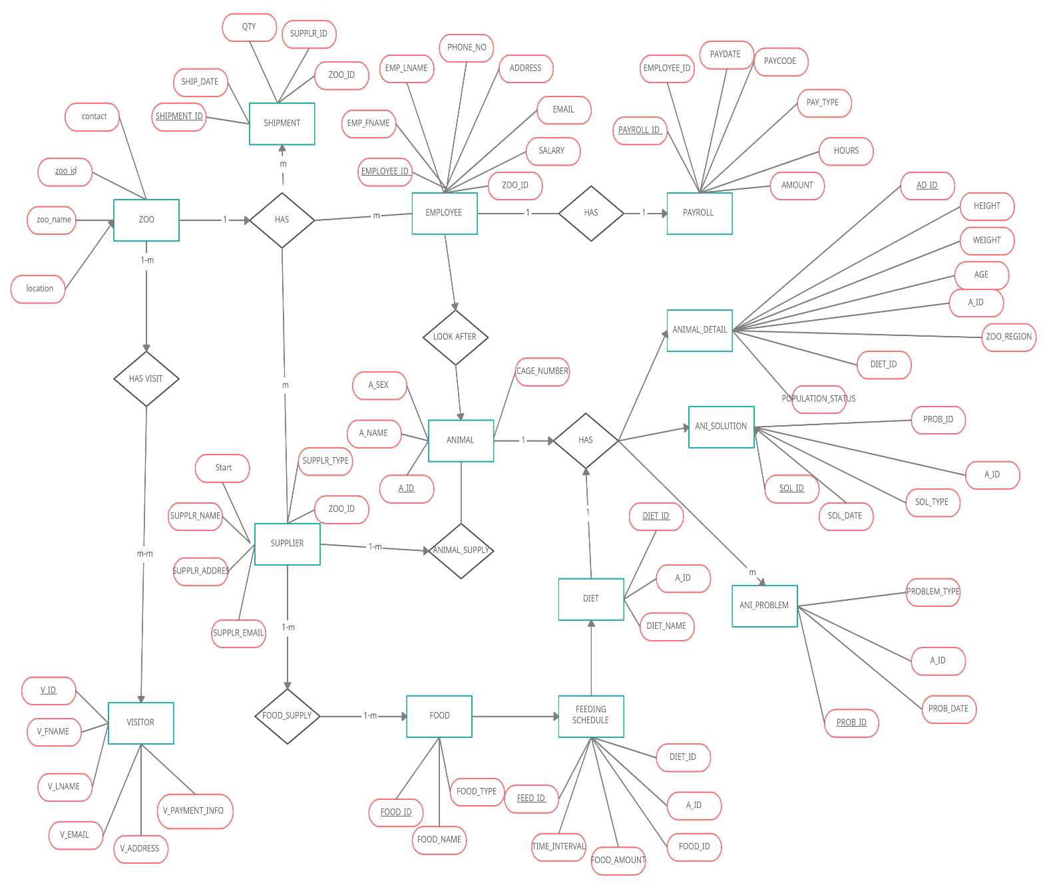

**3.2 Database Design:**

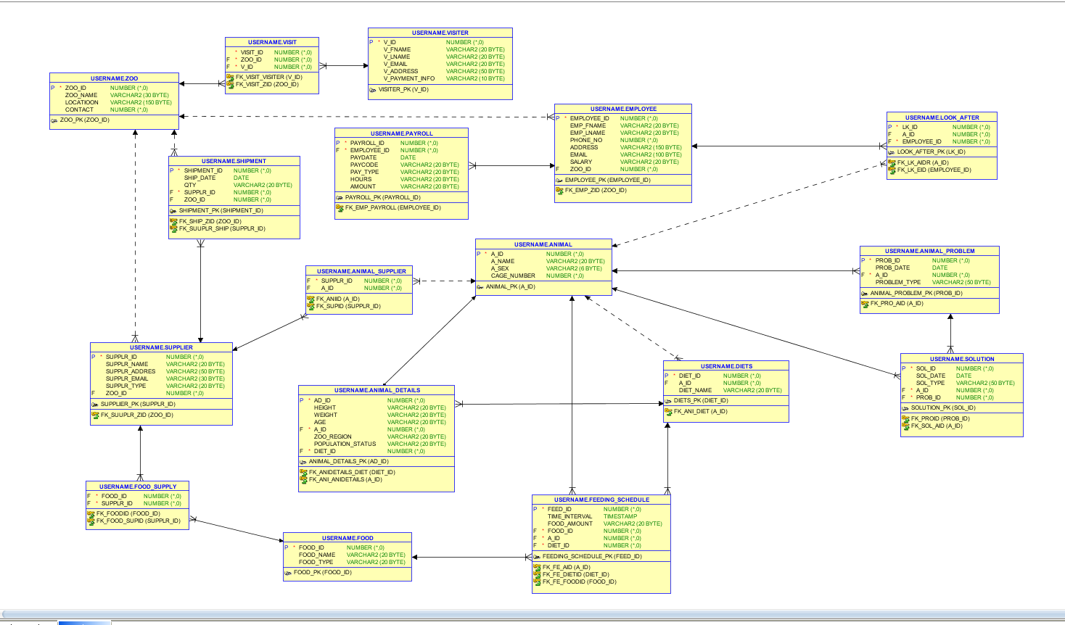

**4. Database Normalization:**

Here We are doing Database Normalization, we looking forward take any advice and suggestion from to make to more accurate.

* **Zoo**

As for normalization the maximum requirement for tables is to be in 3rd normal form (NF). This table is already in 3rd NF.

|  |  |  |  |
| --- | --- | --- | --- |
| **zoo_id** | zoo_name | Location | contact |

* **employee**:

This table is already in 2rd NF. We can take A_id take normalize this table, and create to table that manage which employee take care of which animals

|  |  |  |  |  |  |  |  |  |
| --- | --- | --- | --- | --- | --- | --- | --- | --- |
| **EMPLOYEE_ID** | EMP_FNAME | EMP_LNAME | PHONE_NO | ADDRESS | EMAIL | SALARY | A_ID | ZOO_ID |

**look_after:**

This table manage employee associated with animals

|  |  |  |
| --- | --- | --- |
| **LK_ID** | A_ID | EMPLOYEE_ID |

* **supplier**:

This table in 2nd NF. there is dependency on animal id and food id.

|  |  |  |  |  |  |  |  |
| --- | --- | --- | --- | --- | --- | --- | --- |
| **SUPPLR_ID** | SUPPLR_NAME | SUPPLR_ADDRES | SUPPLR_EMAIL | SUPPLR_TYPE | A_ID | FOOD_ID | ZOO_ID |

To migrate we have to take A_id and FOOD_id out

**animal_supplier:**

|  |  |
| --- | --- |
| SUPPLR_ID | A_ID |

Here we can track which suppler supply which animal

**food_supply**

|  |  |
| --- | --- |
| FOOD_ID | SUPPLR_ID |

Here we can track which suppler supply which food

* **shipment**:

This table is already in 3rd NF.

|  |  |  |  |  |
| --- | --- | --- | --- | --- |
| **SHIPMENT_ID** | SHIP_DATE | QTY | SUPPLR_TYPE | ZOO_ID |

* **visitor**:

This table is in 2nd NF, for for tracking visit count we can take zoo_id and V_id and create new form of table which track records of visits

|  |  |  |  |  |  |  |
| --- | --- | --- | --- | --- | --- | --- |
| **V_ID** | V_FNAME | V_LNAME | V_EMAIL | V_ADDRESS | ZOO_ID | V_PAYMENT_INFO |

**visit**:

|  |  |  |
| --- | --- | --- |
| VISIT_ID | ZOO_ID | V_ID |

This table store all visit records.

* **payroll**:

This table is already in 3rd NF

|  |  |  |  |  |  |  |
| --- | --- | --- | --- | --- | --- | --- |
| **PAYROLL_ID** | EMPLOYEE_ID | PAYDATE | PAYCODE | PAY_TYPE | HOURS | AMOUNT |

* animal:

This table is already in 3rd NF

|  |  |  |  |
| --- | --- | --- | --- |
| **A_ID** | A_NAME | A_SEX | CAGE_NUMBER |

* animal_details

This table is already in 3rd NF

|  |  |  |  |  |  |  |  |
| --- | --- | --- | --- | --- | --- | --- | --- |
| **AD_ID** | HEIGHT | WEIGHT | AGE | A_ID | ZOO_REGION | POPULATION_STATUS | DIET_ID |

* animal_problem

This table is already in 3rd NF

|  |  |  |  |
| --- | --- | --- | --- |
| **PROB_ID** | PROB_DATE | A_ID | PROBLEM_TYPE |

* Diets

This table is already in 3rd NF

|  |  |  |
| --- | --- | --- |
| **DIET_ID** | A_ID | DIET_NAME |

* **feeding_schedule**

This table is already in 3rd NF

|  |  |  |  |  |  |
| --- | --- | --- | --- | --- | --- |
| **FEED_ID** | TIME_INTERVAL | FOOD_AMOUNT | FOOD_ID | A_ID | DIET_ID |

* **Food**

This table is already in 3rd NF

|  |  |  |
| --- | --- | --- |
| **FOOD_ID** | FOOD_NAME | FOOD_TYPE |

* **Solution**

This table is already in 3rd NF

|  |  |  |  |  |
| --- | --- | --- | --- | --- |
| **SOL_ID** | SOL_DATE | SOL_TYPE | A_ID | PROB_ID |

**5. Database Implementation**:

The following code was copied from SQL developer, this was after the team have created their tables. The team came to a collective decision to us the code from SQL developer.

**5.1 Zoo**

CREATE TABLE zoo (

ZOO_ID varchar(20) NOT NULL,

ZOO_NAME varchar(30) DEFAULT NULL,

LOCATIOON varchar(150) DEFAULT NULL,

CONTACT varchar(20) DEFAULT NULL,

PRIMARY KEY (ZOO_ID)

);

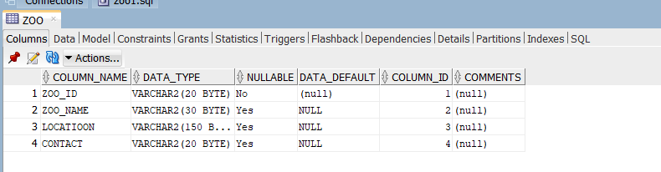

**5.2 Animal**

CREATE table animal (

A_ID varchar(20) NOT NULL,

A_NAME varchar(20) DEFAULT NULL,

A_SEX varchar(6) DEFAULT NULL,

CAGE_NUMBER int DEFAULT NULL,

PRIMARY KEY (A_ID)

) ;

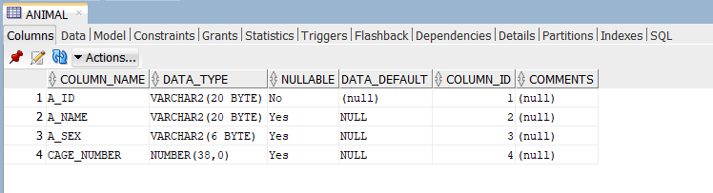

**5.3 EMPLOYEE**

create table EMPLOYEE (

EMPLOYEE_ID varchar(20) NOT NULL,

EMP_FNAME varchar(20) DEFAULT NULL,

EMP_LNAME varchar(20) DEFAULT NULL,

PHONE_NO varchar(20) DEFAULT NULL,

ADDRESS varchar(150) DEFAULT NULL,

EMAIL varchar(100) DEFAULT NULL,

SALARY varchar(20) DEFAULT NULL,

ZOO_ID varchar(20) DEFAULT NULL,

PRIMARY KEY(EMPLOYEE_ID),

CONSTRAINT fk_emp_zid

FOREIGN KEY (ZOO_ID)

REFERENCES zoo(ZOO_ID)

);

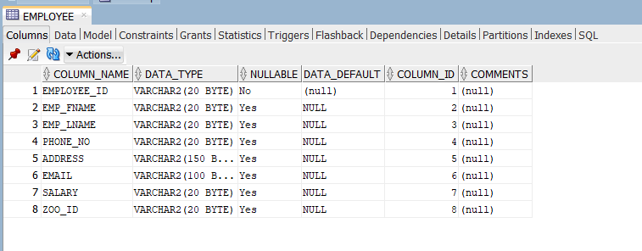

**5.4 supplier**

CREATE TABLE supplier (

SUPPLR_ID varchar(20) NOT NULL,

SUPPLR_NAME varchar(20) DEFAULT NULL,

SUPPLR_ADDRES varchar(50) DEFAULT NULL,

SUPPLR_EMAIL varchar(30) DEFAULT NULL,

SUPPLR_TYPE varchar(20) DEFAULT NULL,

ZOO_ID varchar(20) DEFAULT NULL,

PRIMARY KEY (SUPPLR_ID),

CONSTRAINT fk_suuplr_zid

FOREIGN KEY (ZOO_ID)

REFERENCES zoo(ZOO_ID)

);

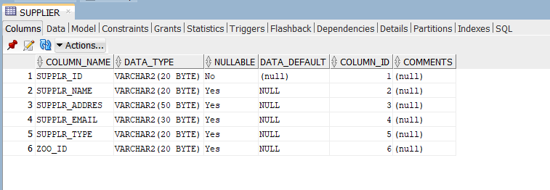

5.5 shipment

CREATE TABLE shipment (

SHIPMENT_ID varchar(20) NOT NULL,

SHIP_DATE date DEFAULT NULL,

QTY varchar(20) DEFAULT NULL,

SUPPLR_ID varchar(20) NOT NULL,

ZOO_ID varchar(20) DEFAULT NULL,

PRIMARY KEY (SHIPMENT_ID),

CONSTRAINT fk_ship_zid

FOREIGN KEY (ZOO_ID)

REFERENCES zoo(ZOO_ID),

CONSTRAINT fk_suuplr_ship

FOREIGN KEY (SUPPLR_ID)

REFERENCES supplier(SUPPLR_ID)

);

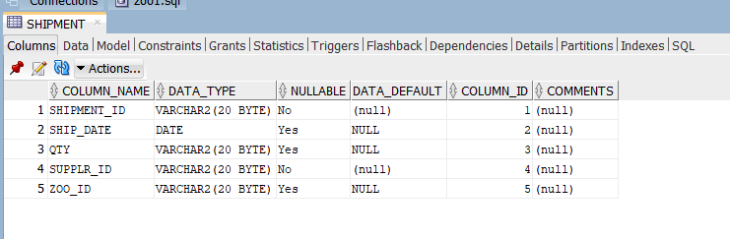

**5.6 visiter**

CREATE TABLE visiter (

V_ID varchar(20) NOT NULL,

V_FNAME varchar(20) DEFAULT NULL,

V_LNAME varchar(20) DEFAULT NULL,

V_EMAIL varchar(20) DEFAULT NULL,

V_ADDRESS varchar(50) DEFAULT NULL,

V_PAYMENT_INFO varchar(10) DEFAULT NULL,

PRIMARY KEY (V_ID)

);

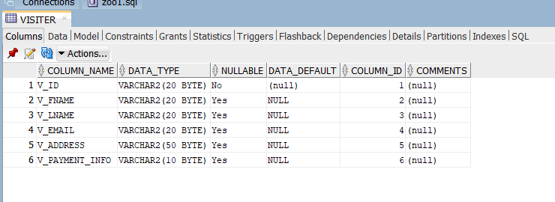

**5.7 visit**

CREATE TABLE visit (

VISIT_ID varchar(20) NOT NULL,

ZOO_ID varchar(20) NOT NULL,

V_ID varchar(20) NOT NULL,

CONSTRAINT fk_visit_zid

FOREIGN KEY (ZOO_ID)

REFERENCES zoo(ZOO_ID),

CONSTRAINT fk_visit_visiter

FOREIGN KEY (V_ID)

REFERENCES visiter(V_ID)

);

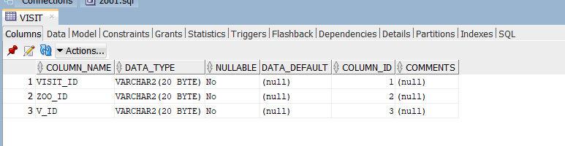

**5.8 payroll**

CREATE TABLE payroll (

PAYROLL_ID varchar(20) NOT NULL,

EMPLOYEE_ID varchar(20) NOT NULL,

PAYDATE date DEFAULT NULL,

PAYCODE varchar(20) DEFAULT NULL,

PAY_TYPE varchar(20) DEFAULT NULL,

HOURS varchar(20) DEFAULT NULL,

AMOUNT varchar(20) DEFAULT NULL,

PRIMARY KEY (PAYROLL_ID),

CONSTRAINT fk_emp_payroll

FOREIGN KEY (EMPLOYEE_ID)

REFERENCES employee(EMPLOYEE_ID)

);

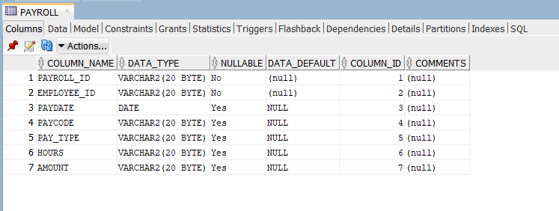

**5.9 animal_details**

CREATE TABLE animal_details (

AD_ID varchar(20) NOT NULL,

HEIGHT varchar(20) DEFAULT NULL,

WEIGHT varchar(20) DEFAULT NULL,

AGE varchar(20) DEFAULT NULL,

A_ID varchar(20) NOT NULL,

ZOO_REGION varchar(20) DEFAULT NULL,

POPULATION_STATUS varchar(20) DEFAULT NULL,

DIET_ID varchar(20) NOT NULL,

primary key (AD_ID),

CONSTRAINT fk_ani_anidetails

FOREIGN KEY (A_ID)

REFERENCES animal(A_ID),

CONSTRAINT fk_anidetails_diet

FOREIGN KEY (DIET_ID)

REFERENCES diets(DIET_ID)

);

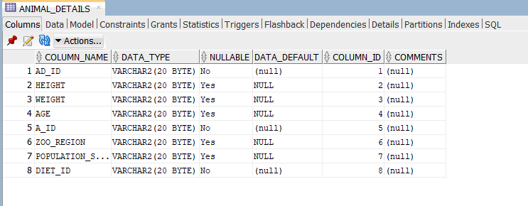

**5.10 animal_problem**

CREATE TABLE animal_problem (

PROB_ID varchar(20) NOT NULL,

PROB_DATE date DEFAULT NULL,

A_ID varchar(20) NOT NULL,

PROBLEM_TYPE varchar(50) DEFAULT NULL,

PRIMARY KEY (PROB_ID),

CONSTRAINT fk_PRO_AID FOREIGN KEY (A_ID) REFERENCES animal (A_ID)

) ;

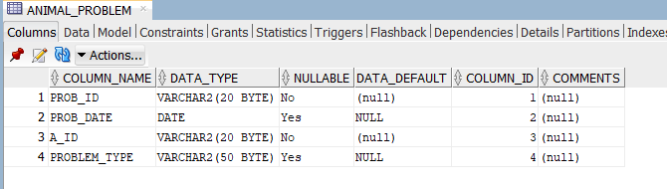

**5.11 Animal_supplier**

CREATE TABLE animal_supplier (

SUPPLR_ID varchar(20) NOT NULL,

A_ID varchar(20) DEFAULT NULL,

CONSTRAINT fk_ANIID FOREIGN KEY (A_ID) REFERENCES animal (A_ID),

CONSTRAINT fk_SUPID FOREIGN KEY (SUPPLR_ID) REFERENCES supplier (SUPPLR_ID)

);

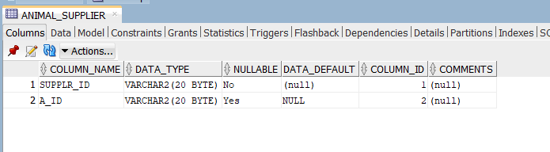

**5.12 Diets**

CREATE TABLE diets (

DIET_ID varchar(20) NOT NULL,

A_ID varchar(20) DEFAULT NULL,

DIET_NAME varchar(20) DEFAULT NULL,

PRIMARY KEY (DIET_ID),

CONSTRAINT fk_ani_diet

FOREIGN KEY (A_ID)

REFERENCES animal(A_ID)

);

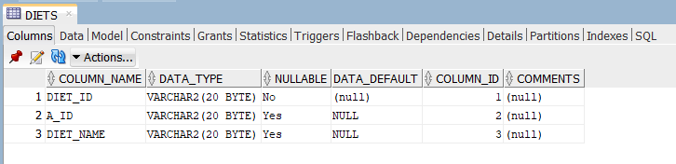

**5.13 feeding_schedule**

CREATE TABLE feeding_schedule (

FEED_ID varchar(20) NOT NULL,

TIME_INTERVAL varchar(20) DEFAULT NULL,

FOOD_AMOUNT varchar(20) DEFAULT NULL,

FOOD_ID varchar(20) NOT NULL,

A_ID varchar(20) NOT NULL,

DIET_ID varchar(20) NOT NULL,

PRIMARY KEY (FEED_ID),

CONSTRAINT fk_FE_AID FOREIGN KEY (A_ID) REFERENCES animal (A_ID),

CONSTRAINT fk_FE_DIETID FOREIGN KEY (DIET_ID) REFERENCES diets (DIET_ID),

CONSTRAINT fk_FE_FOODID FOREIGN KEY (FOOD_ID) REFERENCES food (FOOD_ID)

);

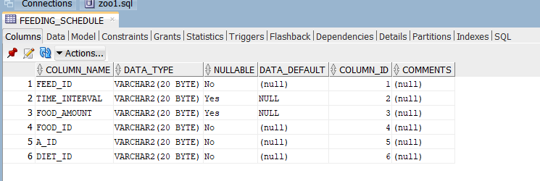

**5.14 food**

CREATE TABLE food (

FOOD_ID varchar(20) NOT NULL,

FOOD_NAME varchar(20) DEFAULT NULL,

FOOD_TYPE varchar(20) DEFAULT NULL,

PRIMARY KEY (FOOD_ID)

) ;

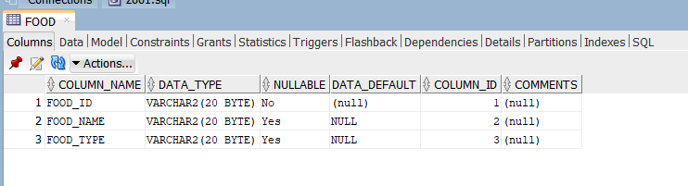

**5.15 food_supply**

CREATE TABLE food_supply (

FOOD_ID varchar(20) NOT NULL,

SUPPLR_ID varchar(20) NOT NULL,

CONSTRAINT fk_FOOD_SUPID FOREIGN KEY (SUPPLR_ID) REFERENCES supplier (SUPPLR_ID),

CONSTRAINT fk_FOODID FOREIGN KEY (FOOD_ID) REFERENCES food (FOOD_ID)

) ;

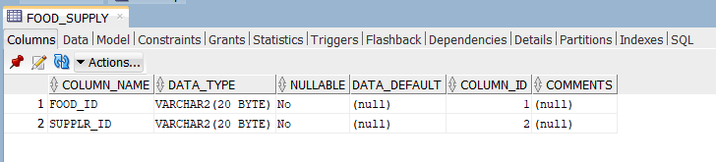

**5.16 look_after**

CREATE TABLE look_after (

LK_ID varchar(20) NOT NULL,

A_ID varchar(20) DEFAULT NULL,

EMPLOYEE_ID varchar(20) NOT NULL,

PRIMARY KEY (LK_ID),

CONSTRAINT fk_LK_AIDr FOREIGN KEY (A_ID) REFERENCES animal (A_ID),

CONSTRAINT fk_LK_EID FOREIGN KEY (EMPLOYEE_ID) REFERENCES employee (EMPLOYEE_ID)

) ;

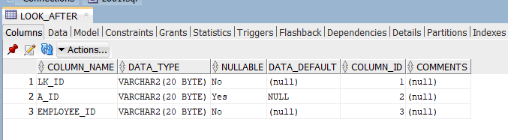

**5.17 solution**

CREATE TABLE solution (

SOL_ID varchar(20) NOT NULL,

SOL_DATE date DEFAULT NULL,

SOL_TYPE varchar(50) DEFAULT NULL,

A_ID varchar(20) NOT NULL,

PROB_ID varchar(20) NOT NULL,

PRIMARY KEY (SOL_ID),

CONSTRAINT fk_PROID FOREIGN KEY (PROB_ID) REFERENCES animal_problem (PROB_ID),

CONSTRAINT fk_SOL_AID FOREIGN KEY (A_ID) REFERENCES animal (A_ID)

) ;

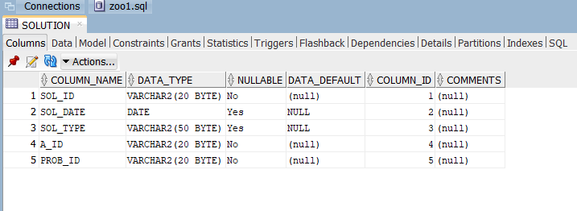

**6. Data Insertion:**

**6.1 ZOO**

INSERT INTO ZOO (ZOO_ID, zoo_name,LOCATIOON,CONTACT ) VALUES (1, 'Amazon','Birmingham City',0241234);



**6.2 ANIMAL**

INSERT INTO ANIMAL (A_ID,A_NAME,A_SEX,CAGE_NUMBER ) VALUES ('A001', 'Chimpy', 'F',1);

INSERT INTO ANIMAL (A_ID,A_NAME,A_SEX,CAGE_NUMBER ) VALUES('A002', 'Lame Lion', 'M',2);

INSERT INTO ANIMAL (A_ID,A_NAME,A_SEX,CAGE_NUMBER ) VALUES('A003', 'Egor the Elephant','M',3);

INSERT INTO ANIMAL (A_ID,A_NAME,A_SEX,CAGE_NUMBER ) VALUES('A004', 'Roo the Kangaroo','F',4);

INSERT INTO ANIMAL (A_ID,A_NAME,A_SEX,CAGE_NUMBER ) VALUES('A005', 'Wolfy the Wolf',

'M',5);

INSERT INTO ANIMAL (A_ID,A_NAME,A_SEX,CAGE_NUMBER ) VALUES('A006', 'Hater Gator', 'F',6);

INSERT INTO ANIMAL (A_ID,A_NAME,A_SEX,CAGE_NUMBER ) VALUES('A007', 'ZIBRA', 'F',7);

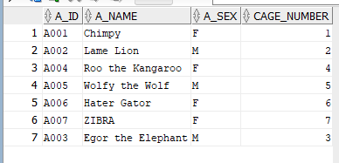

**6.3 ANIMAL_DETAILS**

INSERT INTO ANIMAL_DETAILS (AD_ID,HEIGHT,WEIGHT,AGE,A_ID,ZOO_REGION,POPULATION_STATUS,DIET_ID) VALUES ('AD001','34', '100','7', 'A001', 'NORTH', 'AVARAGE', 'D001');

INSERT INTO ANIMAL_DETAILS (AD_ID,HEIGHT,WEIGHT,AGE,A_ID,ZOO_REGION,POPULATION_STATUS,DIET_ID) VALUES ('AD002','45','180','10', 'A002', 'NORTH', 'GOOD', 'D002');

INSERT INTO ANIMAL_DETAILS (AD_ID,HEIGHT,WEIGHT,AGE,A_ID,ZOO_REGION,POPULATION_STATUS,DIET_ID) VALUES ('AD003','60','500','15', 'A003', 'NORTH', 'GOOD', 'D003');

INSERT INTO ANIMAL_DETAILS (AD_ID,HEIGHT,WEIGHT,AGE,A_ID,ZOO_REGION,POPULATION_STATUS,DIET_ID) VALUES ('AD004','32','160','12', 'A004', 'SOUTH', 'AVARAGE', 'D004');

INSERT INTO ANIMAL_DETAILS (AD_ID,HEIGHT,WEIGHT,AGE,A_ID,ZOO_REGION,POPULATION_STATUS,DIET_ID) VALUES ('AD005','30','150','10', 'A005', 'EAST', 'BELOW AVARAGE','D005');

INSERT INTO ANIMAL_DETAILS (AD_ID,HEIGHT,WEIGHT,AGE,A_ID,ZOO_REGION,POPULATION_STATUS,DIET_ID) VALUES ('AD006','20','130','17', 'A006', 'SOUTH','GOOD', 'D006');

INSERT INTO ANIMAL_DETAILS (AD_ID,HEIGHT,WEIGHT,AGE,A_ID,ZOO_REGION,POPULATION_STATUS,DIET_ID) VALUES ('AD007','25','130','20', 'A007', 'EAST', 'GOOD', 'D007');

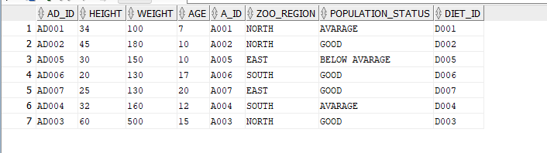

**6.4 ANIMAL_PROBLEM**

INSERT INTO ANIMAL_PROBLEM (PROB_ID,PROB_DATE,A_ID,PROBLEM_TYPE )VALUES('P001',TO_DATE('2021-04-08','yyyy/mm/dd'), 'A001', 'Medical');

INSERT INTO ANIMAL_PROBLEM (PROB_ID,PROB_DATE,A_ID,PROBLEM_TYPE )VALUES('P002',TO_DATE('2021-03-21','yyyy/mm/dd'), 'A005', 'Maintenance');

INSERT INTO ANIMAL_PROBLEM (PROB_ID,PROB_DATE,A_ID,PROBLEM_TYPE )VALUES('P003',TO_DATE('2021-05-12','yyyy/mm/dd'), 'A007', 'Animal Behavior');

INSERT INTO ANIMAL_PROBLEM (PROB_ID,PROB_DATE,A_ID,PROBLEM_TYPE )VALUES('P004',TO_DATE('2021-06-22','yyyy/mm/dd'), 'A002', 'Medical');

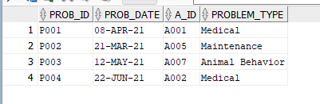

**6.5 ANIMAL_SUPPLIER**

INSERT INTO ANIMAL_SUPPLIER (SUPPLR_ID,A_ID) VALUES('S002', 'A001');

INSERT INTO ANIMAL_SUPPLIER (SUPPLR_ID,A_ID) VALUES('S002', 'A002');

INSERT INTO ANIMAL_SUPPLIER (SUPPLR_ID,A_ID) VALUES('S002', 'A003');

INSERT INTO ANIMAL_SUPPLIER (SUPPLR_ID,A_ID) VALUES('S004', 'A004');

INSERT INTO ANIMAL_SUPPLIER (SUPPLR_ID,A_ID) VALUES('S005', 'A005');

INSERT INTO ANIMAL_SUPPLIER (SUPPLR_ID,A_ID) VALUES('S004', 'A006');

INSERT INTO ANIMAL_SUPPLIER (SUPPLR_ID,A_ID) VALUES('S002', 'A007');

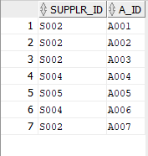

**6.6 DIETS**

INSERT INTO DIETS (DIET_ID,A_ID,DIET_NAME ) VALUES ('D001', 'A001', 'Vegan Diet');

INSERT INTO DIETS (DIET_ID,A_ID,DIET_NAME ) VALUES('D002', 'A002', 'Dukan Diet');

INSERT INTO DIETS (DIET_ID,A_ID,DIET_NAME ) VALUES('D003', 'A003', 'Atkins Diet');

INSERT INTO DIETS (DIET_ID,A_ID,DIET_NAME ) VALUES('D004', 'A004', 'Low-Carb Diets');

INSERT INTO DIETS (DIET_ID,A_ID,DIET_NAME ) VALUES('D005', 'A005', 'Dukan Diet');

INSERT INTO DIETS (DIET_ID,A_ID,DIET_NAME ) VALUES('D006', 'A006', 'Atkins Diet');

INSERT INTO DIETS (DIET_ID,A_ID,DIET_NAME ) VALUES('D007', 'A007', 'Low-Carb Diets');

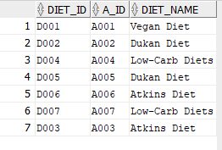

**6.7 EMPLOYEE**

INSERT INTO EMPLOYEE (EMPLOYEE_ID,EMP_FNAME,EMP_LNAME,PHONE_NO,ADDRESS,EMAIL,SALARY,ZOO_ID )VALUES('101','HEMAL', 'KARODIYA', '+04 34334','','','$3000','1');

INSERT INTO EMPLOYEE (EMPLOYEE_ID,EMP_FNAME,EMP_LNAME,PHONE_NO,ADDRESS,EMAIL,SALARY,ZOO_ID )VALUES('102','MANPREET', 'SINGH', '+23 23233','','','$3500','1');

INSERT INTO EMPLOYEE (EMPLOYEE_ID,EMP_FNAME,EMP_LNAME,PHONE_NO,ADDRESS,EMAIL,SALARY,ZOO_ID )VALUES('103','ALEX', 'MIRIYANI', '+23 34563','','','$3000','1');

INSERT INTO EMPLOYEE (EMPLOYEE_ID,EMP_FNAME,EMP_LNAME,PHONE_NO,ADDRESS,EMAIL,SALARY,ZOO_ID )VALUES('104','JOHN', 'HODSON', '+14 23423','','','$2800','1');

INSERT INTO EMPLOYEE (EMPLOYEE_ID,EMP_FNAME,EMP_LNAME,PHONE_NO,ADDRESS,EMAIL,SALARY,ZOO_ID )VALUES('105','MIR', 'ALI', '+12 35353','','','$3200','1');

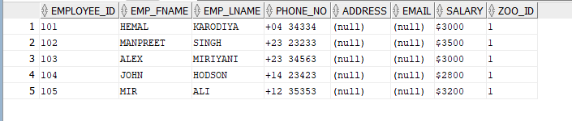

**6.8 FEEDING_SCHEDULE**

INSERT INTO FEEDING_SCHEDULE (FEED_ID,TIME_INTERVAL,FOOD_AMOUNT,FOOD_ID,A_ID,DIET_ID ) VALUES ('FE001', '3 hours', '3 pounds', 'F002', 'A001', 'D001');

INSERT INTO FEEDING_SCHEDULE (FEED_ID,TIME_INTERVAL,FOOD_AMOUNT,FOOD_ID,A_ID,DIET_ID ) VALUES ('FE002', '5 hours', '5 pounds', 'F005', 'A002', 'D002');

INSERT INTO FEEDING_SCHEDULE (FEED_ID,TIME_INTERVAL,FOOD_AMOUNT,FOOD_ID,A_ID,DIET_ID ) VALUES ('FE003', '3 hours', '7 pounds', 'F002', 'A003', 'D003');

INSERT INTO FEEDING_SCHEDULE (FEED_ID,TIME_INTERVAL,FOOD_AMOUNT,FOOD_ID,A_ID,DIET_ID ) VALUES ('FE004', '2 hours', '3 pounds', 'F001', 'A004', 'D004');

INSERT INTO FEEDING_SCHEDULE (FEED_ID,TIME_INTERVAL,FOOD_AMOUNT,FOOD_ID,A_ID,DIET_ID ) VALUES ('FE005', '1 hours', '6 pounds', 'F005', 'A005', 'D005');

INSERT INTO FEEDING_SCHEDULE (FEED_ID,TIME_INTERVAL,FOOD_AMOUNT,FOOD_ID,A_ID,DIET_ID ) VALUES ('FE006', '5 hours', '2 pounds', 'F004', 'A006', 'D006');

INSERT INTO FEEDING_SCHEDULE (FEED_ID,TIME_INTERVAL,FOOD_AMOUNT,FOOD_ID,A_ID,DIET_ID ) VALUES ('FE007', '3 hours', '1 pounds', 'F003', 'A007', 'D007');

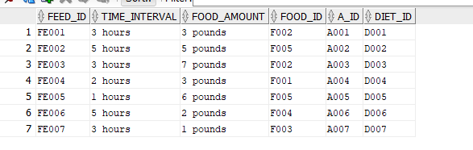

**6.9 FOOD**

INSERT INTO FOOD (FOOD_ID,FOOD_NAME,FOOD_TYPE ) VALUES ('F001', 'oats', 'VEG');

INSERT INTO FOOD (FOOD_ID,FOOD_NAME,FOOD_TYPE ) VALUES('F002', 'bananas', 'VEG');

INSERT INTO FOOD (FOOD_ID,FOOD_NAME,FOOD_TYPE ) VALUES('F003', 'apples', 'VEG');

INSERT INTO FOOD (FOOD_ID,FOOD_NAME,FOOD_TYPE ) VALUES('F004', 'eggs', 'NON-VEG');

INSERT INTO FOOD (FOOD_ID,FOOD_NAME,FOOD_TYPE ) VALUES('F005', 'meat', 'NON-VEG');

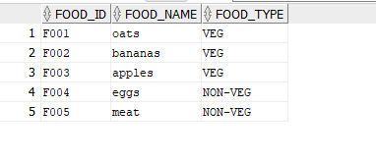

**6.10 FOOD_SUPPLY**

INSERT INTO FOOD_SUPPLY (FOOD_ID,SUPPLR_ID) VALUES ('F001', 'S003');

INSERT INTO FOOD_SUPPLY (FOOD_ID,SUPPLR_ID) VALUES('F002', 'S003');

INSERT INTO FOOD_SUPPLY (FOOD_ID,SUPPLR_ID) VALUES('F003', 'S003');

INSERT INTO FOOD_SUPPLY (FOOD_ID,SUPPLR_ID) VALUES('F004', 'S001');

INSERT INTO FOOD_SUPPLY (FOOD_ID,SUPPLR_ID) VALUES('F005', 'S001');

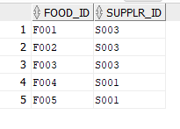

**6.11 LOOK_AFTER**

INSERT INTO LOOK_AFTER(LK_ID,A_ID,EMPLOYEE_ID)VALUES('L001', 'A001', '101');

INSERT INTO LOOK_AFTER(LK_ID,A_ID,EMPLOYEE_ID)VALUES('L002', 'A002', '101');

INSERT INTO LOOK_AFTER(LK_ID,A_ID,EMPLOYEE_ID)VALUES('L003', 'A003', '102');

INSERT INTO LOOK_AFTER(LK_ID,A_ID,EMPLOYEE_ID)VALUES('L004', 'A004', '102');

INSERT INTO LOOK_AFTER(LK_ID,A_ID,EMPLOYEE_ID)VALUES('L005', 'A005', '103');

INSERT INTO LOOK_AFTER(LK_ID,A_ID,EMPLOYEE_ID)VALUES('L006', 'A006', '104');

INSERT INTO LOOK_AFTER(LK_ID,A_ID,EMPLOYEE_ID)VALUES('L007', 'A007', '105');

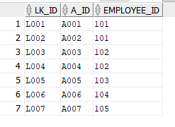

**6.12 PAYROLL**

INSERT INTO PAYROLL (PAYROLL_ID,EMPLOYEE_ID,PAYDATE,PAYCODE,PAY_TYPE,HOURS,AMOUNT )VALUES ('P001','101', TO_DATE('2021-06-14','yyyy/mm/dd'), 'H', 'HOURS', '40', '300');

INSERT INTO PAYROLL (PAYROLL_ID,EMPLOYEE_ID,PAYDATE,PAYCODE,PAY_TYPE,HOURS,AMOUNT )VALUES('P002','102', TO_DATE('2021-06-14','yyyy/mm/dd'), 'H', 'HOURS', '32', '260');

INSERT INTO PAYROLL (PAYROLL_ID,EMPLOYEE_ID,PAYDATE,PAYCODE,PAY_TYPE,HOURS,AMOUNT )VALUES('P003','103', TO_DATE('2021-06-14','yyyy/mm/dd'), 'H', 'HOURS', '36', '290');

INSERT INTO PAYROLL (PAYROLL_ID,EMPLOYEE_ID,PAYDATE,PAYCODE,PAY_TYPE,HOURS,AMOUNT )VALUES('P004','104', TO_DATE('2021-06-14','yyyy/mm/dd'), 'H', 'HOURS', '40', '300');

INSERT INTO PAYROLL (PAYROLL_ID,EMPLOYEE_ID,PAYDATE,PAYCODE,PAY_TYPE,HOURS,AMOUNT )VALUES('P005','105', TO_DATE('2021-06-14','yyyy/mm/dd'), 'H', 'HOURS', '30', '250');

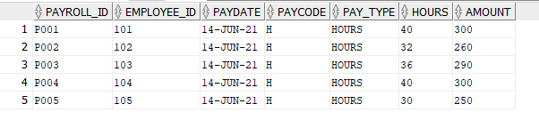

**6.13 SHIPMENT**

INSERT INTO SHIPMENT(SHIPMENT_ID,SHIP_DATE,QTY,SUPPLR_ID,ZOO_ID )VALUES('SH001',TO_DATE('2021-03-04','yyyy/mm/dd'), '1780', 'S001', '1');

INSERT INTO SHIPMENT(SHIPMENT_ID,SHIP_DATE,QTY,SUPPLR_ID,ZOO_ID )VALUES('SH002',TO_DATE('2021-04-12','yyyy/mm/dd'), '1380', 'S002', '1');

INSERT INTO SHIPMENT(SHIPMENT_ID,SHIP_DATE,QTY,SUPPLR_ID,ZOO_ID )VALUES('SH003',TO_DATE('2021-05-01','yyyy/mm/dd'), '1970', 'S003', '1');

INSERT INTO SHIPMENT(SHIPMENT_ID,SHIP_DATE,QTY,SUPPLR_ID,ZOO_ID )VALUES('SH004',TO_DATE('2021-06-13','yyyy/mm/dd'), '2120', 'S001', '1');

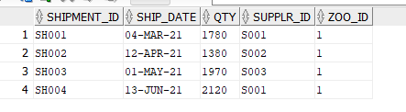

**6.14 SOLUTION**

INSERT INTO SOLUTION(SOL_ID,SOL_DATE,SOL_TYPE,A_ID,PROB_ID )VALUES('S001',TO_DATE('2021-04-10','yyyy/mm/dd'), 'One week Antibiotics','A001','P001');

INSERT INTO SOLUTION(SOL_ID,SOL_DATE,SOL_TYPE,A_ID,PROB_ID )VALUES('S002',TO_DATE('2021-03-29','yyyy/mm/dd'),'Isolation', 'A005','P002');

INSERT INTO SOLUTION(SOL_ID,SOL_DATE,SOL_TYPE,A_ID,PROB_ID )VALUES('S003',TO_DATE('2021-05-20','yyyy/mm/dd'),'ONE Month Antibiotics','A007','P003');

INSERT INTO SOLUTION(SOL_ID,SOL_DATE,SOL_TYPE,A_ID,PROB_ID )VALUES('S004',TO_DATE('2021-06-27','yyyy/mm/dd'),'One week Antibiotics','A002','P004');

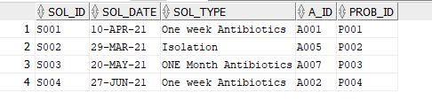

**6.15 SUPPLIER**

INSERT INTO SUPPLIER (SUPPLR_ID,SUPPLR_NAME,SUPPLR_ADDRES,SUPPLR_EMAIL,SUPPLR_TYPE,ZOO_ID ) VALUES ('S001','WallyWorld', '4827 Wilkinson Court','WallyWorld@gmail.com', 'FOOD', '1');

INSERT INTO SUPPLIER (SUPPLR_ID,SUPPLR_NAME,SUPPLR_ADDRES,SUPPLR_EMAIL,SUPPLR_TYPE,ZOO_ID ) VALUES('S002','Joyce Rides', '1277 Filbert Street', 'Joyce@gmail.com', 'ANIMAL', '1');

INSERT INTO SUPPLIER (SUPPLR_ID,SUPPLR_NAME,SUPPLR_ADDRES,SUPPLR_EMAIL,SUPPLR_TYPE,ZOO_ID ) VALUES('S003','Riley Supplies','233 South Street','Riley@gmail.com','FOOD','1');

INSERT INTO SUPPLIER (SUPPLR_ID,SUPPLR_NAME,SUPPLR_ADDRES,SUPPLR_EMAIL,SUPPLR_TYPE,ZOO_ID ) VALUES('S004','Petco', 'San Antonio', 'Petco@gmail.com', 'ANIMAL', '1');

INSERT INTO SUPPLIER (SUPPLR_ID,SUPPLR_NAME,SUPPLR_ADDRES,SUPPLR_EMAIL,SUPPLR_TYPE,ZOO_ID ) VALUES('S005','Animart','6232 Robin Road', 'Animart@gmail.com', 'ANIMAL','1');

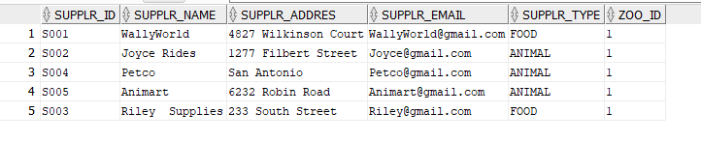

**6.16 VISIT**

INSERT INTO VISIT (VISIT_ID,ZOO_ID,V_ID ) VALUES ('VS001', '1', 'V001');

INSERT INTO VISIT (VISIT_ID,ZOO_ID,V_ID ) VALUES('VS002', '1', 'V002');

INSERT INTO VISIT (VISIT_ID,ZOO_ID,V_ID ) VALUES('VS003', '1', 'V003');

INSERT INTO VISIT (VISIT_ID,ZOO_ID,V_ID ) VALUES('VS004', '1', 'V004');

INSERT INTO VISIT (VISIT_ID,ZOO_ID,V_ID ) VALUES('VS005', '1', 'V004');

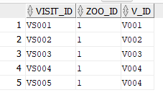

**6.17 VISITER**

INSERT INTO VISITER (V_ID,V_FNAME,V_LNAME,V_EMAIL,V_ADDRESS,V_PAYMENT_INFO ) VALUES ('V001','Jon', 'Kane', 'jon@gmail.com', 'South road street', 'CASH');

INSERT INTO VISITER (V_ID,V_FNAME,V_LNAME,V_EMAIL,V_ADDRESS,V_PAYMENT_INFO ) VALUES('V002','Nataile', 'Hodson','Nataile@gmail.com', 'Walls site', 'CASH');

INSERT INTO VISITER (V_ID,V_FNAME,V_LNAME,V_EMAIL,V_ADDRESS,V_PAYMENT_INFO ) VALUES('V003','Emmy', 'Geller', 'Emmy@gmail.com', 'Valet east', 'CASH');

INSERT INTO VISITER (V_ID,V_FNAME,V_LNAME,V_EMAIL,V_ADDRESS,V_PAYMENT_INFO ) VALUES('V004','Frank', 'noordoor','Frank@gmail.com', '24 homeland', 'ONLINE');

INSERT INTO VISITER (V_ID,V_FNAME,V_LNAME,V_EMAIL,V_ADDRESS,V_PAYMENT_INFO ) VALUES('V005','Rachel', 'Green','Rachel@gmail.com', '08 pollar north', 'ONLINE');

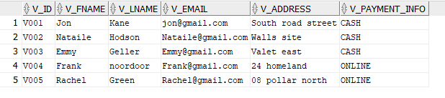

**7. SQL Queries**

In this section we are testing some queries of our database

1. suppose We have to find total count of zoo visit.

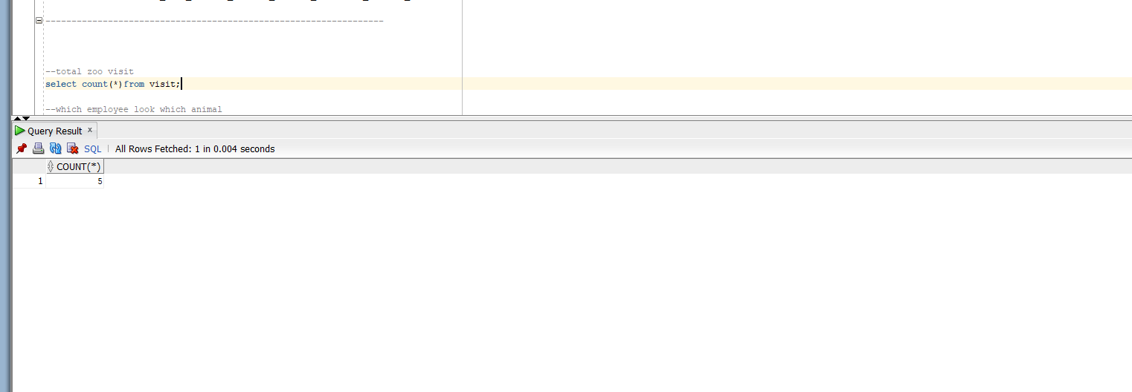

1. Suppose we want to see which employee look after which animal

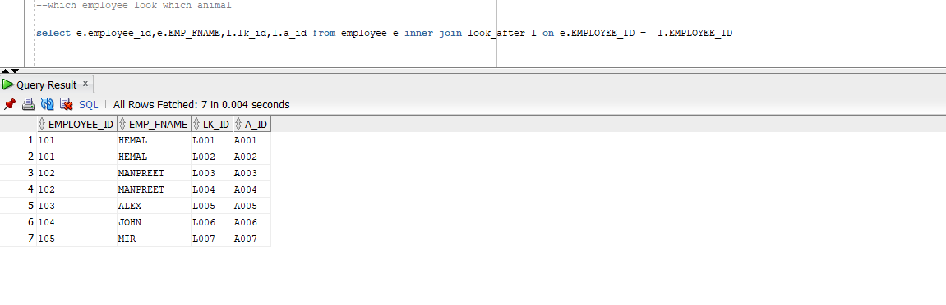

1. Suppose if we want to see animal A005 is look after by which employee

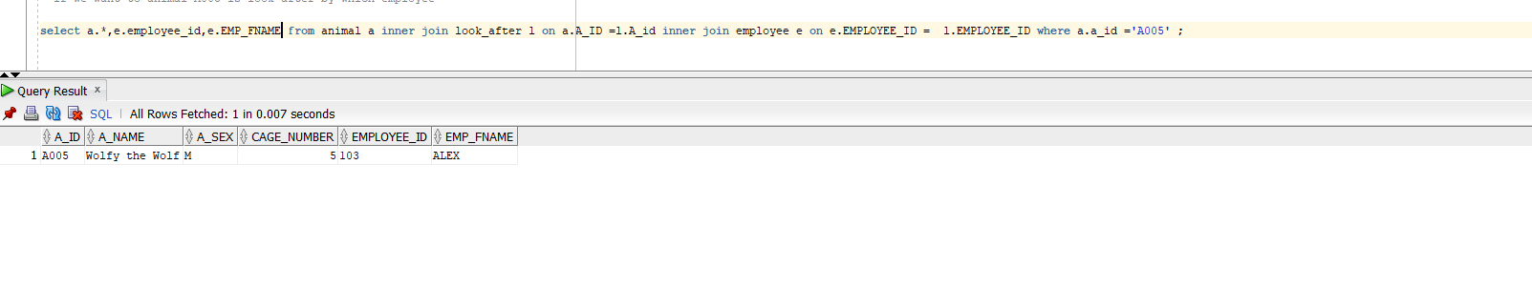

1. if we want to see animal’s full details

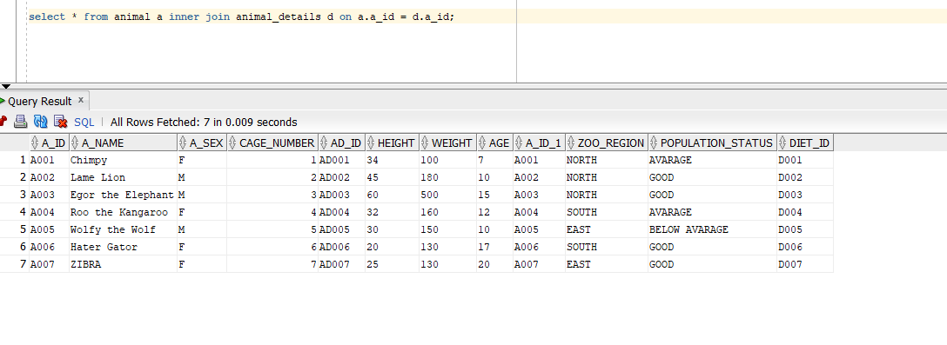

1. E mployee payroll details

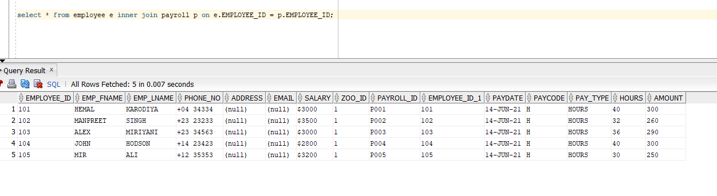

1. if we want to see animal problem



1. check the solution for anima problem

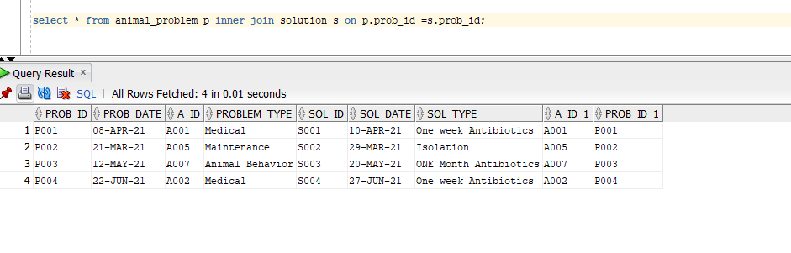

1. want to see which animal followed which diet

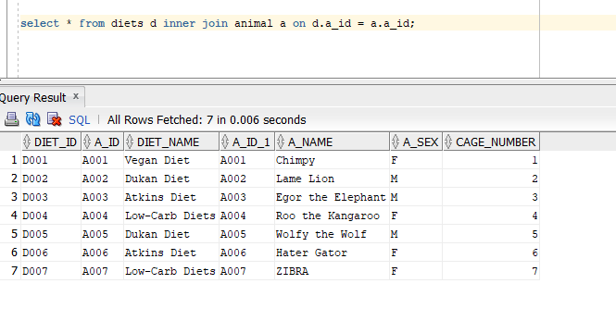

1. want to see animal feeding schedule

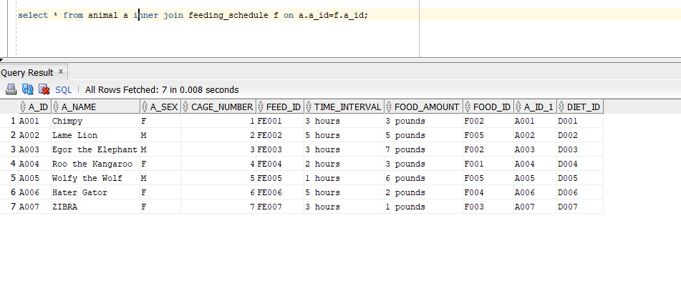

1. want wo see which animal supplied by which supplier

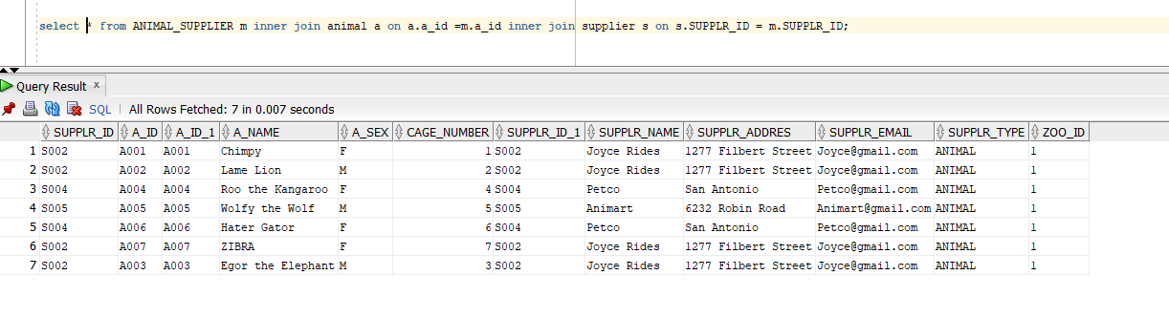

1. want to which food supplied by which supplier

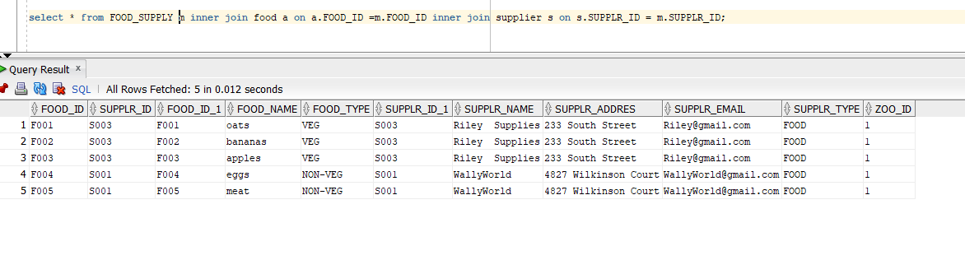

1. want to see which supplier supplied their supplement

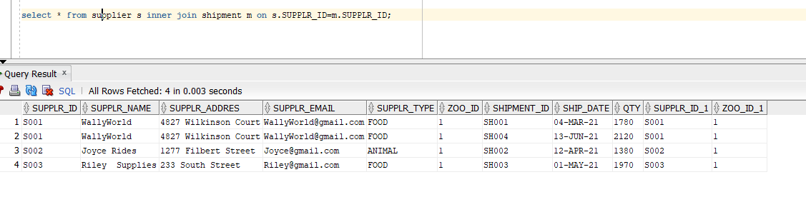

**8. Conclusions**

We create zoo management database. First, we created ER diagram to obtain well design database. Team face challenge in creating a relationship between entities. It was also necessary to do normalization to ensure that the tables were in the maximum 3rd NF. We also tested some queries to show performance of database. In outcome we delivered well design Database, which is used by zoo to maintain daily records and run business smooth way.

**9. References:**

How to setup oracle. solution center:

https://www.oracle.com/tools/downloads/sqldev-downloads.html#sqldev-install-windows